Raw number:<br />

<b><?= $value ?></b>

</p>

<P>

Formatted number:<br />

<b><?= NumberHelper::format($value) ?></b>

</p>

</div>

4. Open the action. You should see the following result:

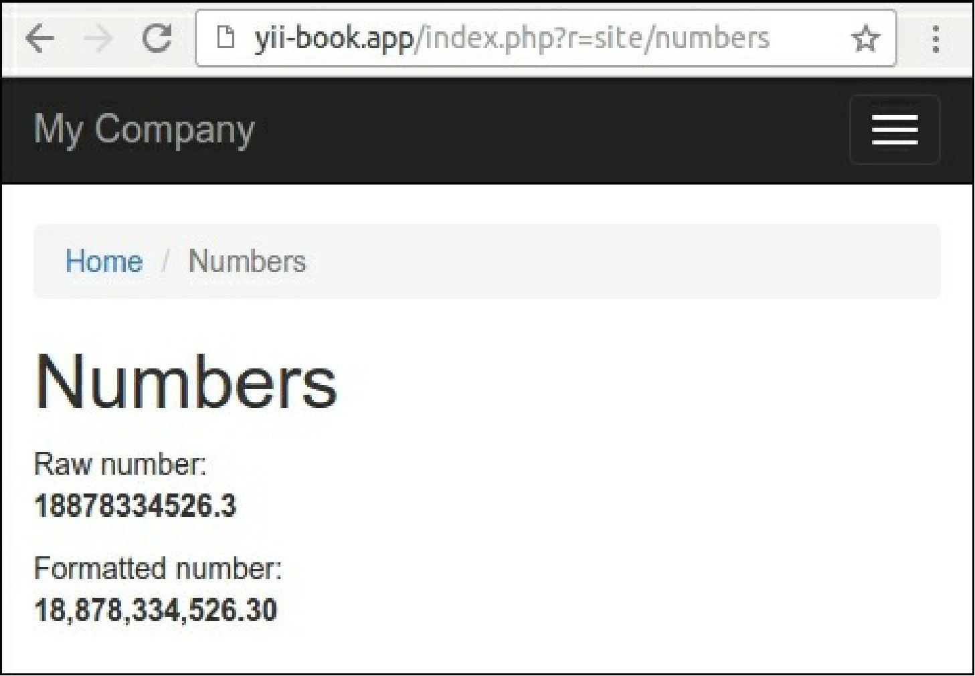

In other cases, you can specify another count of decimal numbers. Observe the following example: NumberHelper::format($value, 3)

How it works...

Any helper in Yii2 is just a set of functions, implemented as static methods in the corresponding classes.

You can use a helper for implementing any different formats of output, for manipulations with values of any variables, and for other cases.

Note

Usually, static helpers are lightweight clean functions with a small count of arguments. Avoid putting your business logic and other complicated manipulations into helpers. Use widgets or other components instead of helpers in other cases.